Snippet Expands To
sysout System.out.println();
sysoutv System.out.println("var = " + var);
main public static void main(String[] args) {}
for for (int i = 0; i < ; i++) {} I think it fori
foreach Enhanced for loop
if if () {}
try try { } catch (Exception e) { }

Zoom text in editor + terminal
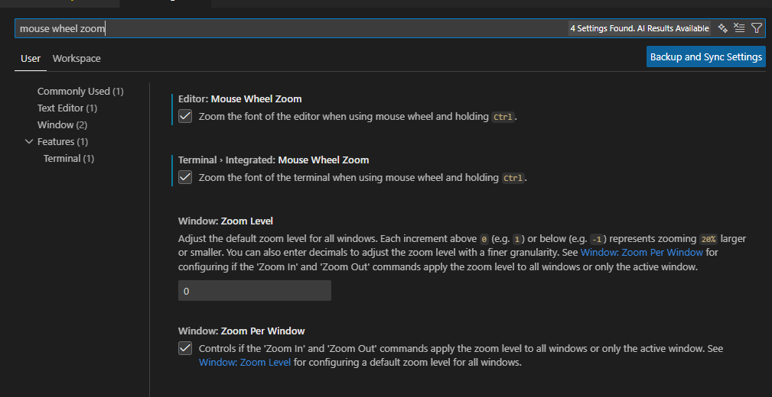

Disable parameter hint
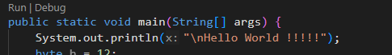
Turn it off
